Evidence Gathering Document for SQA Level 8 Professional Developer Award.

This document is designed for you to present your screenshots and diagrams relevant to the PDA and to also give a short description of what you are showing to clarify understanding for the assessor.

Please fill in each point with screenshot or diagram and description of what you are showing.



Each point requires details that cover each element of the Assessment Criteria, along with a brief description of the kind of things you should be showing.

**Week 2**

| Unit | Ref | Evidence |  |
| --- | --- | --- | --- |
| I&T | I.T.5 | Demonstrate the use of an array in a program. Take screenshots of:  *An array in a program  *A function that uses the array  *The result of the function running | |
|  |  | **Description:** | |

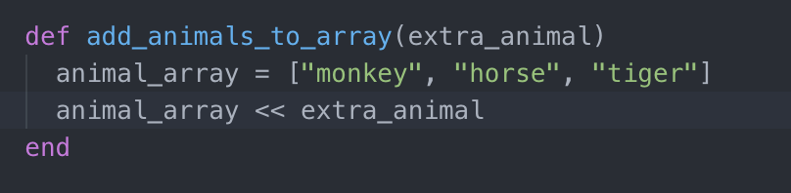

An array in a function in a program

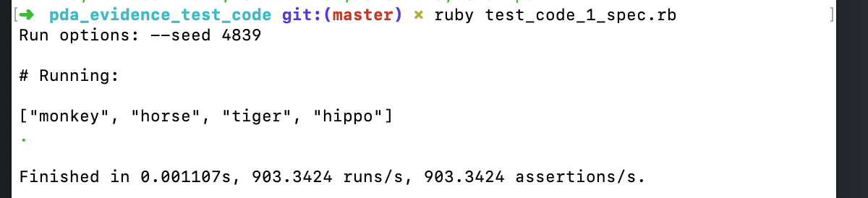

The result of the function running

| Unit | Ref | Evidence |  |
| --- | --- | --- | --- |
| I&T | I.T.6 | Demonstrate the use of a hash in a program. Take screenshots of:  *A hash in a program  *A function that uses the hash  *The result of the function running | |
|  |  | **Description:** | |

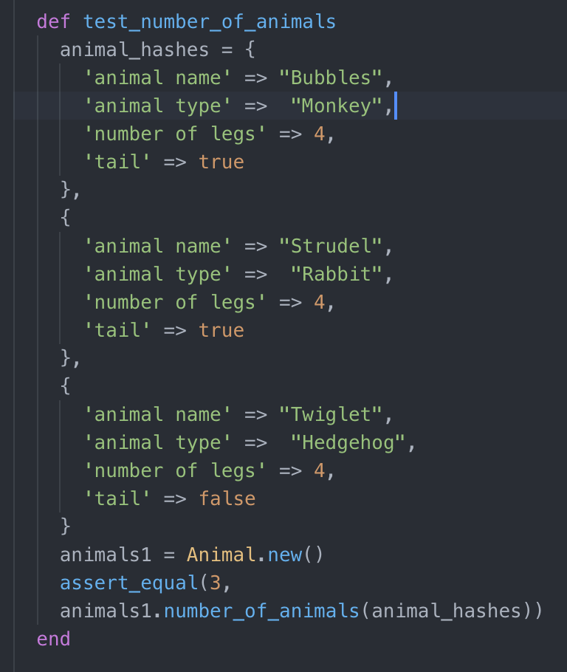

A hash in a program

**Paste Screenshot here**

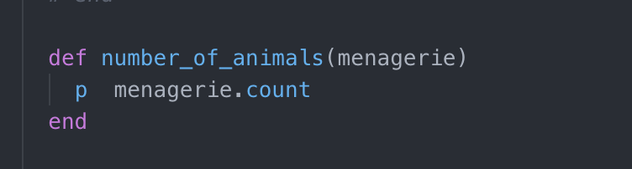

A function that uses the hash

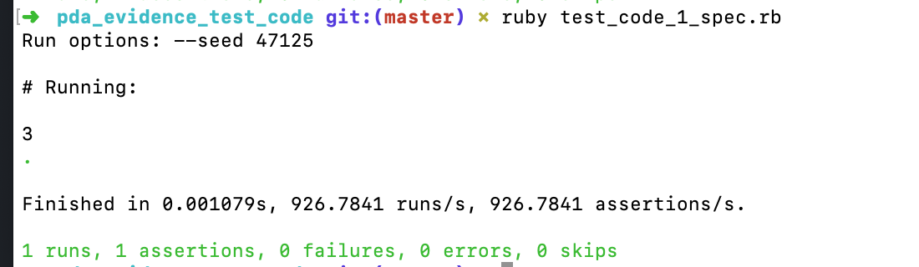

The result of running the function

**Week 3**

| Unit | Ref | Evidence |  |
| --- | --- | --- | --- |
| I&T | I.T.3 | Demonstrate searching data in a program. Take screenshots of:  *Function that searches data  *The result of the function running | |
|  |  | **Description:** | |

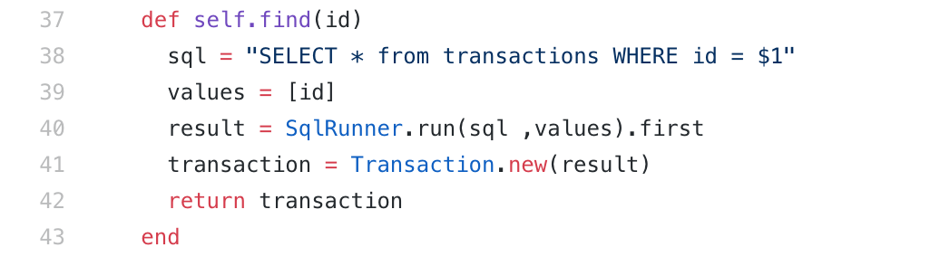

A function that searches data

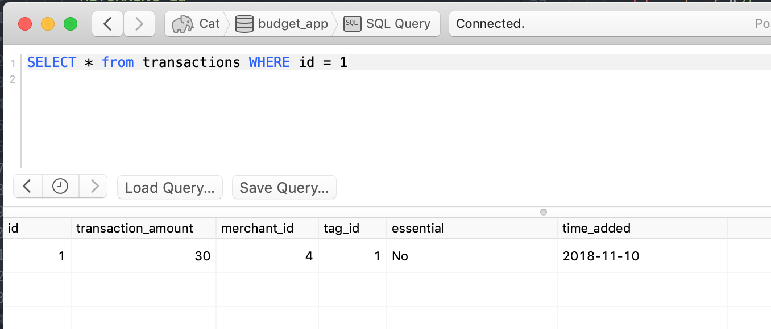

The result of the function running

| Unit | Ref | Evidence |  |
| --- | --- | --- | --- |
| I&T | I.T.4 | Demonstrate sorting data in a program. Take screenshots of:  *Function that sorts data  *The result of the function running | |
|  |  | **Description:** | |

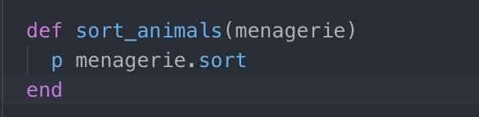

Function that sorts data

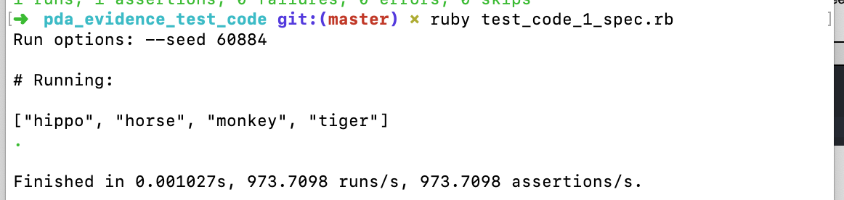

Result of running the sort function

**Week 5 and 6**

| Unit | Ref | Evidence |  |
| --- | --- | --- | --- |
| A&D | A.D.1 | A Use Case Diagram | |
|  |  | **Description:** | |

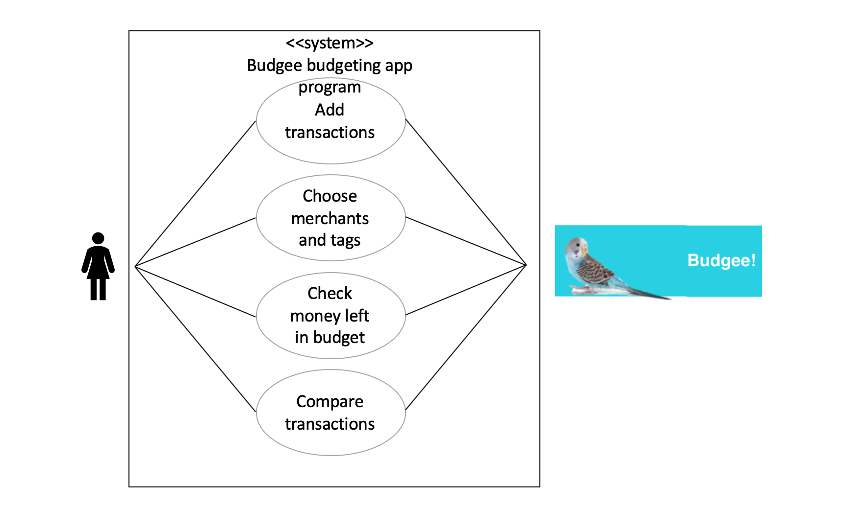

Case diagram for budget app - Ruby Project

| Unit | Ref | Evidence |  |
| --- | --- | --- | --- |
| A&D | A.D.2 | A Class Diagram | |
|  |  | **Description:** | |

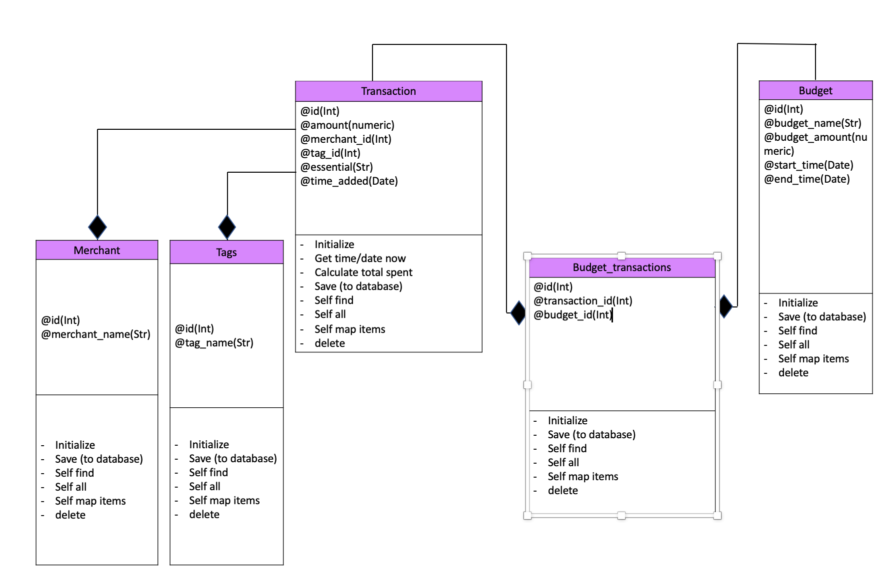

Class diagram of Ruby budget app project

| Unit | Ref | Evidence |  |
| --- | --- | --- | --- |
| A&D | A.D.3 | An Object Diagram | |
|  |  | **Description:** | |

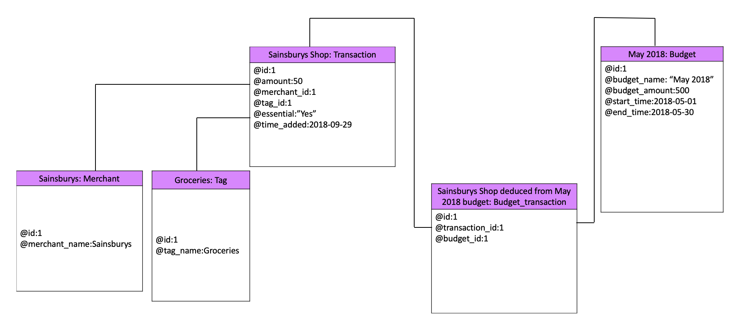

Object diagram of Ruby budget app project

| Unit | Ref | Evidence |  |
| --- | --- | --- | --- |
| A&D | A.D.4 | An Activity Diagram | |
|  |  | **Description:** | |

**Paste Screenshot here**

**Description here**

| Unit | Ref | Evidence |  |
| --- | --- | --- | --- |
| A&D | A.D.6 | Produce an Implementations Constraints plan detailing the following factors:  *Hardware and software platforms  *Performance requirements  *Persistent storage and transactions  *Usability  *Budgets  *Time | |
|  |  | **Description:** | |

**Paste Screenshot here**

**Description here**

| Unit | Ref | Evidence |  |
| --- | --- | --- | --- |
| P | P.5 | User Site Map | |
|  |  | **Description:** | |

**Paste Screenshot here**

**Description here**

| Unit | Ref | Evidence |  |
| --- | --- | --- | --- |
| P | P.6 | 2 Wireframe Diagrams | |
|  |  | **Description:** | |

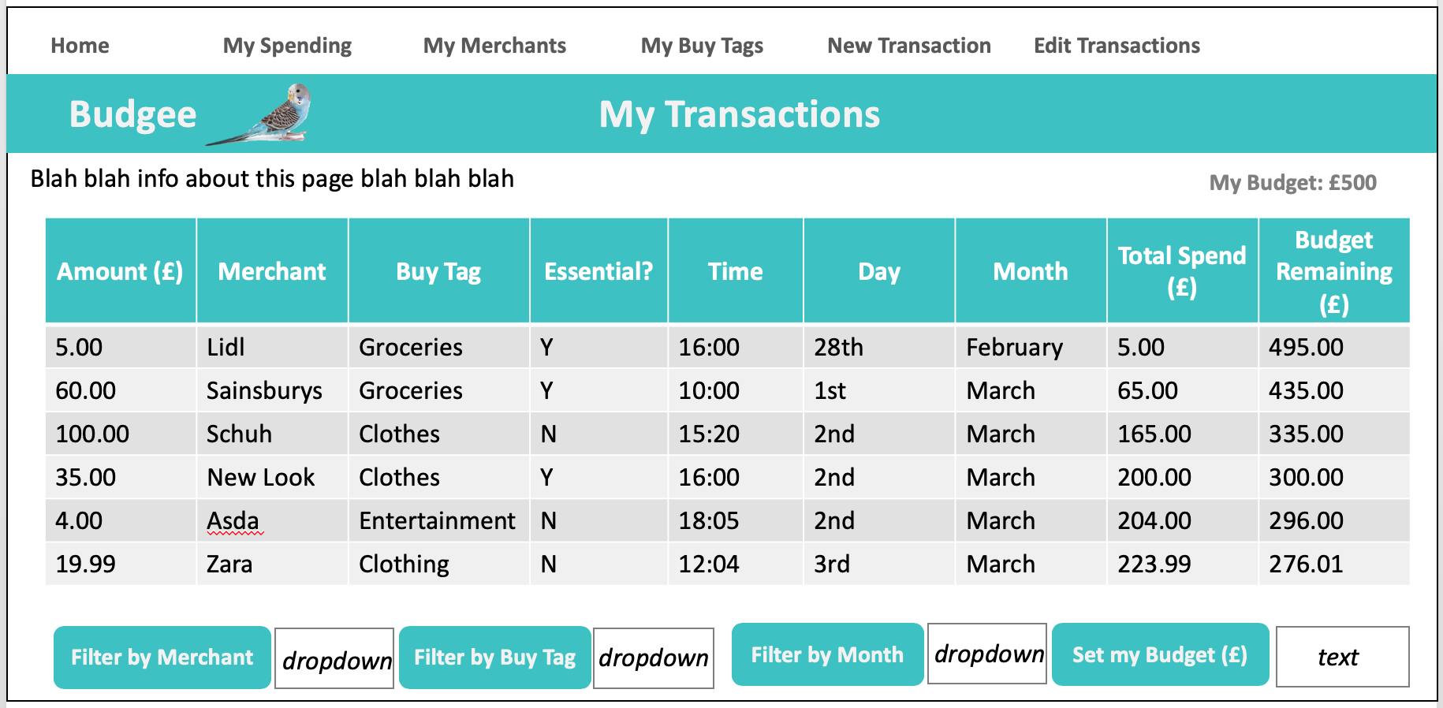

Wireframe diagram showing Transactions page in Ruby budget app project

| Unit | Ref | Evidence |  |
| --- | --- | --- | --- |
| P | P.10 | Example of Pseudocode used for a method | |
|  |  | **Description:** | |

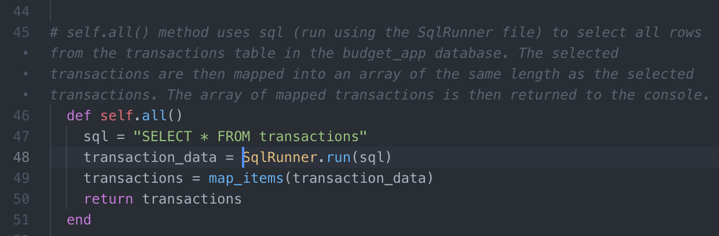

Example of pseudocode used for the self.all method in Ruby budget app project

| Unit | Ref | Evidence |  |
| --- | --- | --- | --- |
| P | P.13 | Show user input being processed according to design requirements. Take a screenshot of:  * The user inputting something into your program  * The user input being saved or used in some way | |
|  |  | **Description:** | |

**Paste Screenshot here**

**Description here**

| Unit | Ref | Evidence |  |
| --- | --- | --- | --- |
| P | P.14 | Show an interaction with data persistence. Take a screenshot of:  * Data being inputted into your program  * Confirmation of the data being saved | |
|  |  | **Description:** | |

**Paste Screenshot here**

**Description here**

| Unit | Ref | Evidence |  |
| --- | --- | --- | --- |
| P | P.15 | Show the correct output of results and feedback to user. Take a screenshot of:  * The user requesting information or an action to be performed  * The user request being processed correctly and demonstrated in the program | |
|  |  | **Description:** | |

**Paste Screenshot here**

**Description here**

| Unit | Ref | Evidence |  |
| --- | --- | --- | --- |
| P | P.11 | Take a screenshot of one of your projects where you have worked alone and attach the Github link. | |
|  |  | **Description:** | |

**Paste Screenshot here**

**Description here**

| Unit | Ref | Evidence |  |
| --- | --- | --- | --- |
| P | P.12 | Take screenshots or photos of your planning and the different stages of development to show changes. | |
|  |  | **Description:** | |

**Paste Screenshot here**

**Description here**

**Week 7**

| Unit | Ref | Evidence |  |
| --- | --- | --- | --- |
| P | P.16 | Show an API being used within your program. Take a screenshot of:  * The code that uses or implements the API  * The API being used by the program whilst running | |
|  |  | **Description:** | |

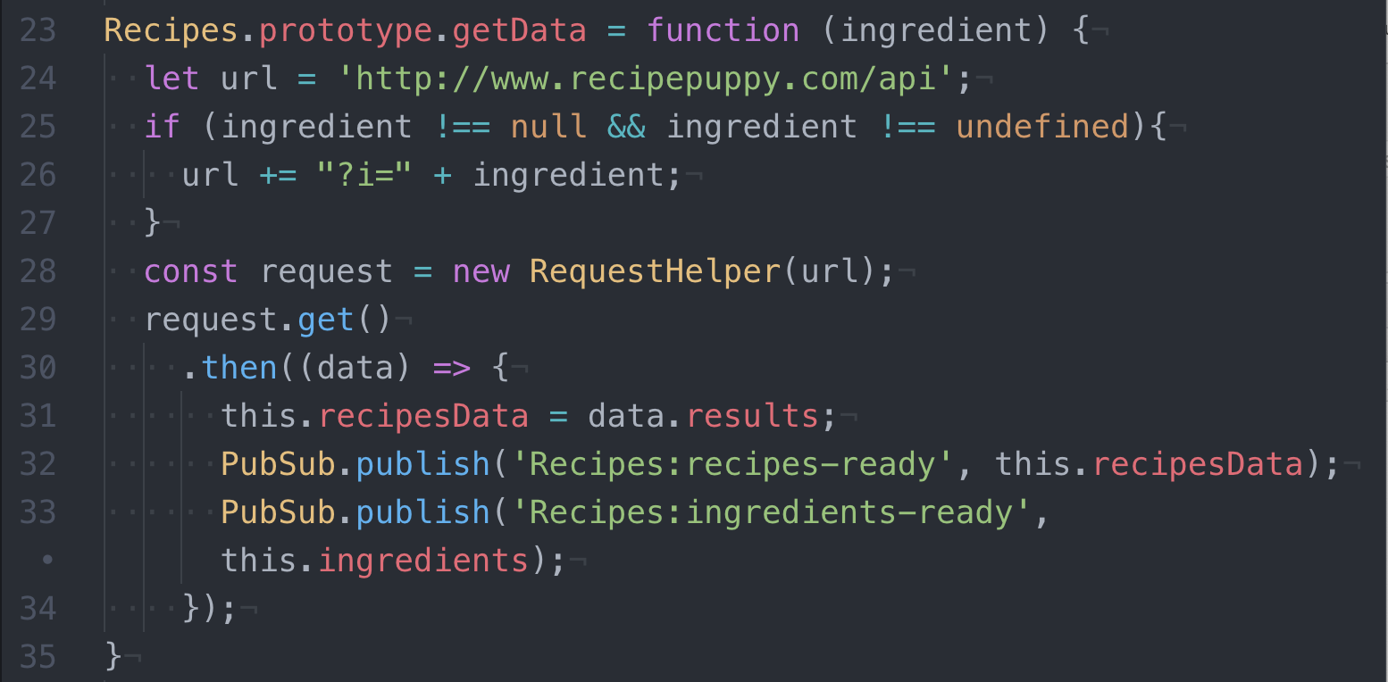

Code that uses or implements the API

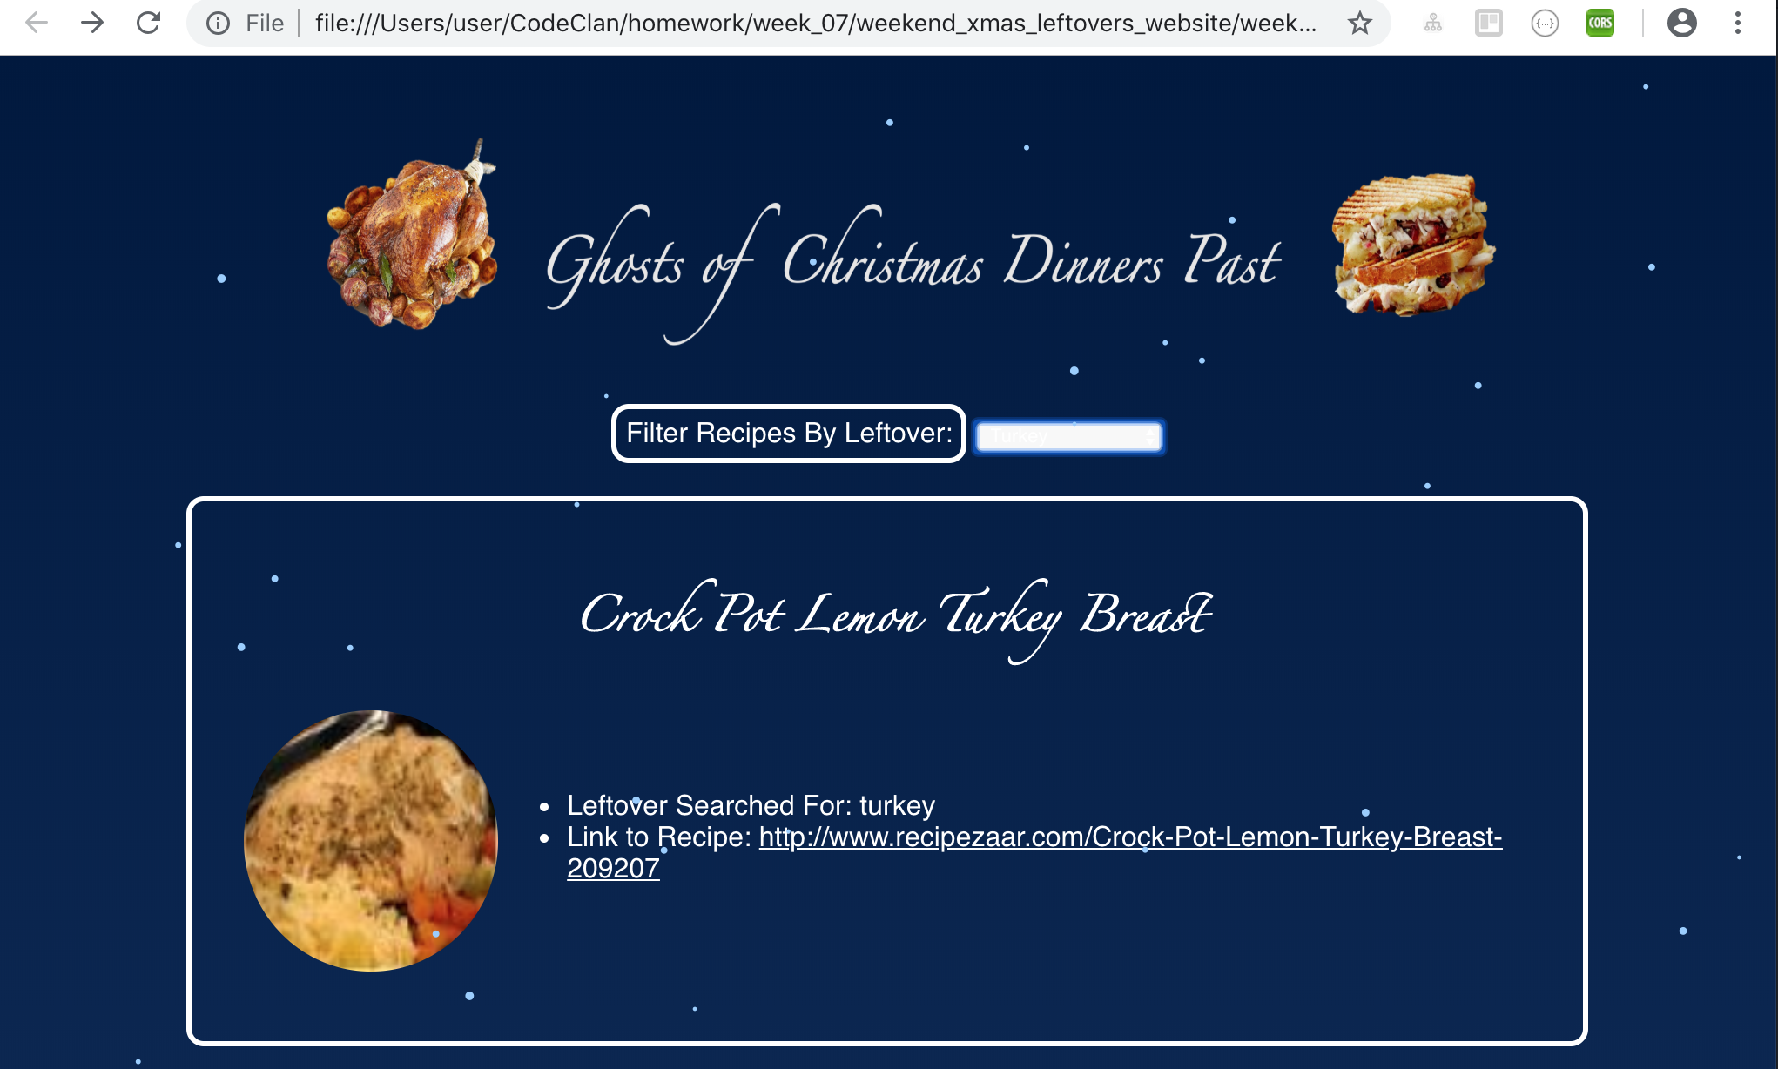

The API being used by the program whilst running

| Unit | Ref | Evidence |  |
| --- | --- | --- | --- |
| P | P.18 | Demonstrate testing in your program. Take screenshots of:  * Example of test code  * The test code failing to pass  * Example of the test code once errors have been corrected  * The test code passing | |
|  |  | **Description:** | |

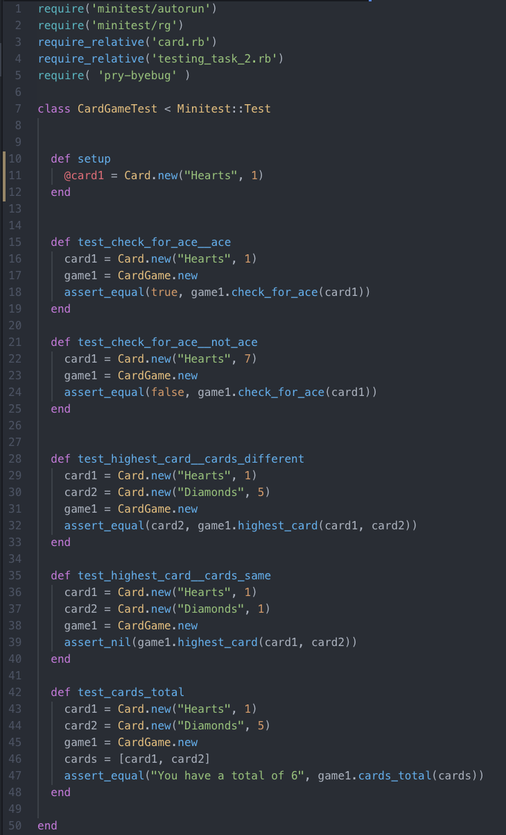

Example of Test Code

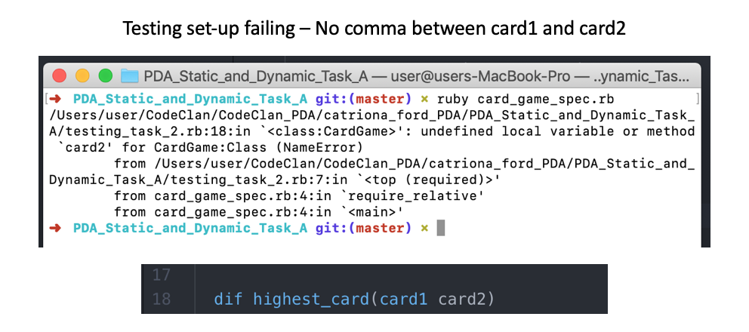

Testing set-up failing

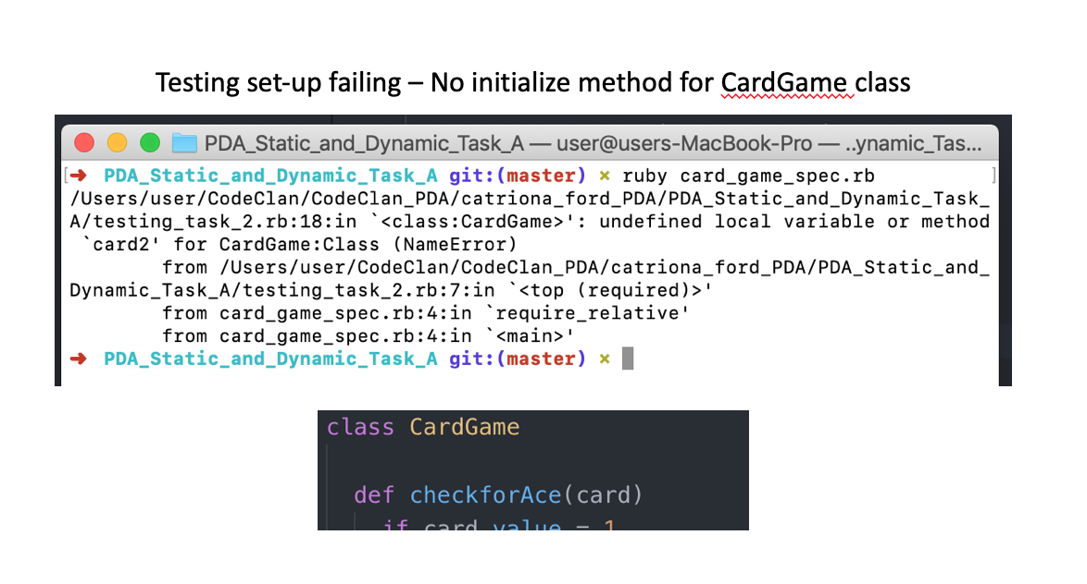

Testing Set-up Failing

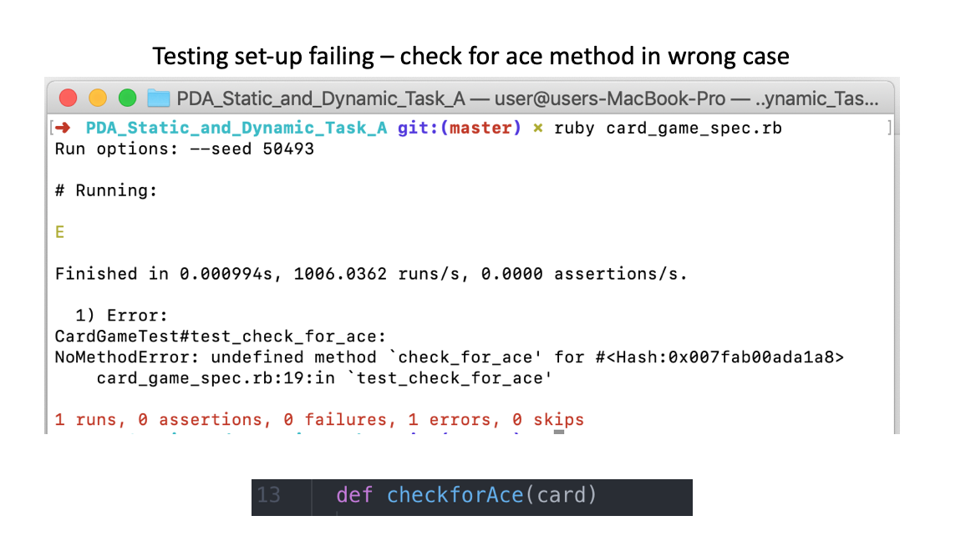

Test set-up failing

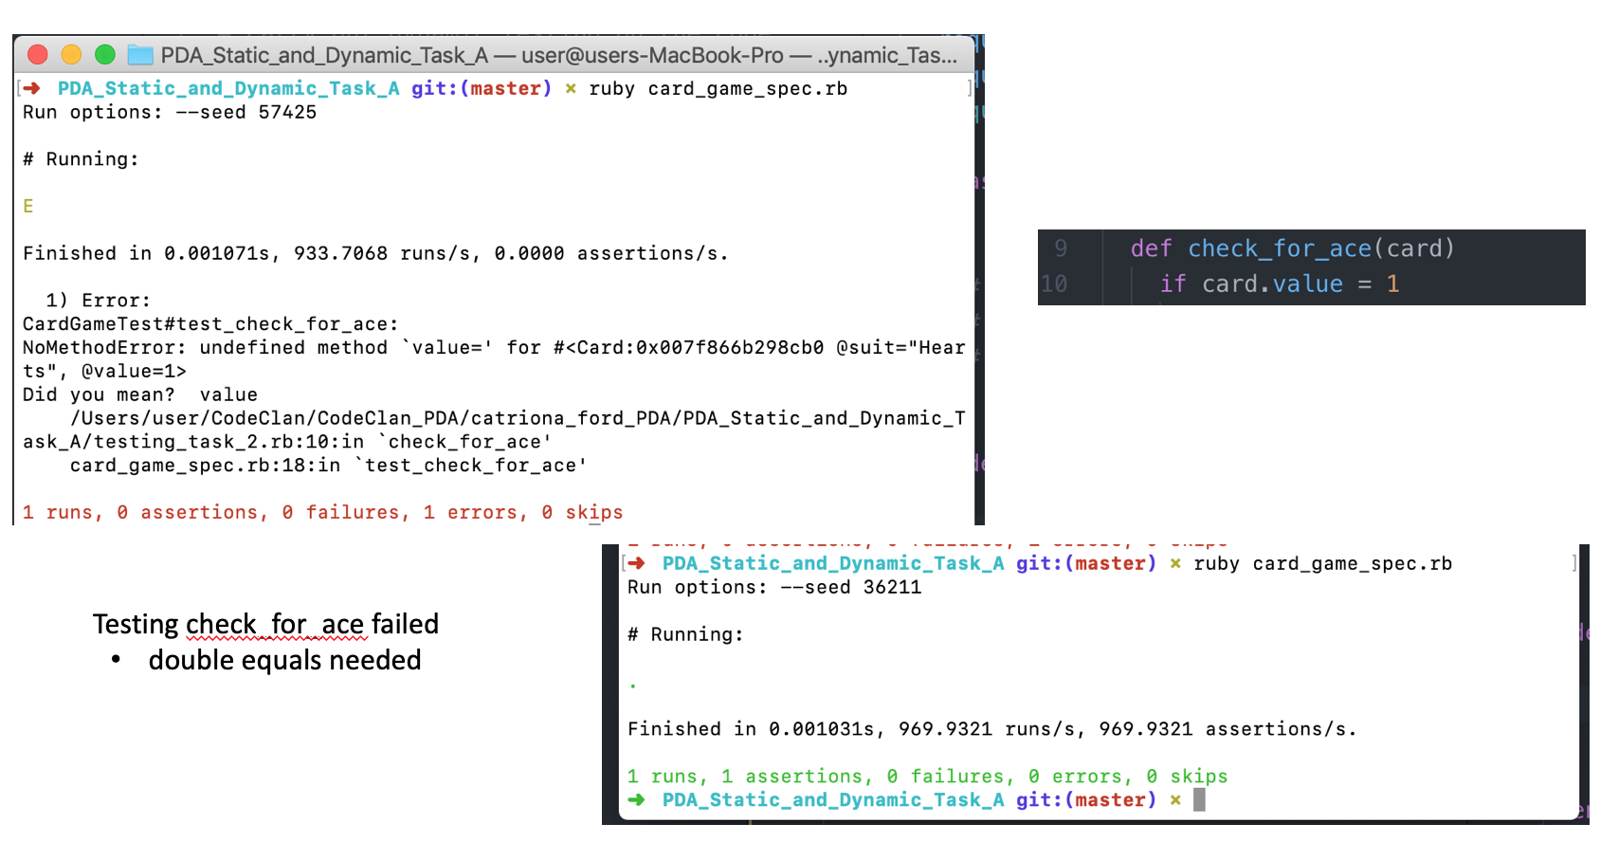

Tests for check_for_ace method failing then passing

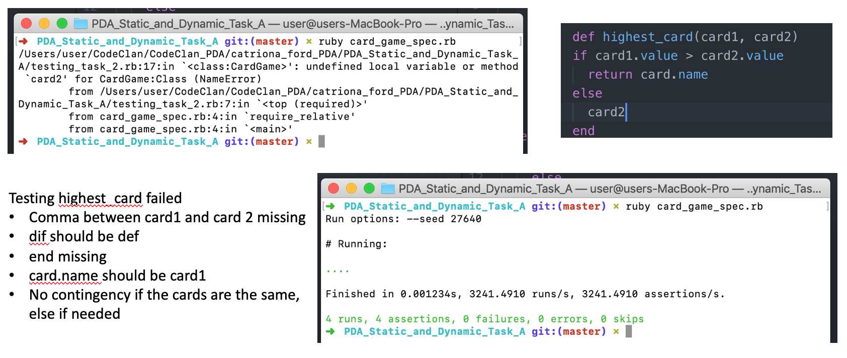

Tests for highest_card method failing then passing

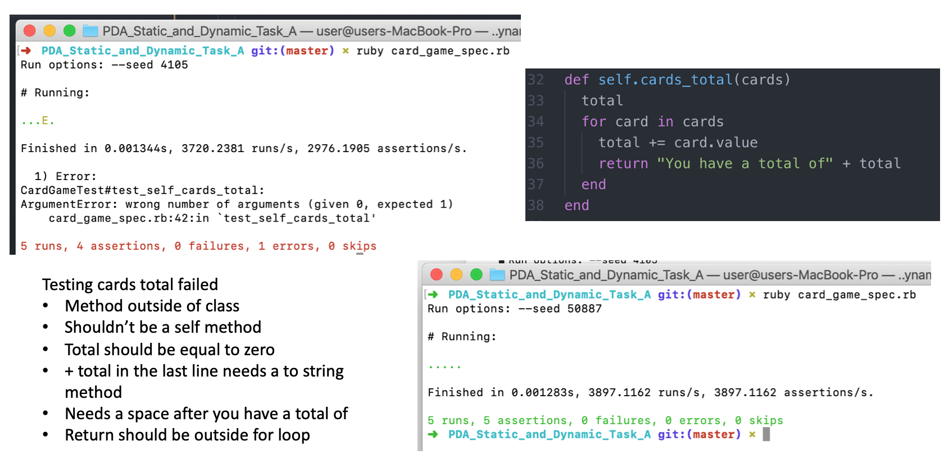

Tests for cards_total method failing then passing

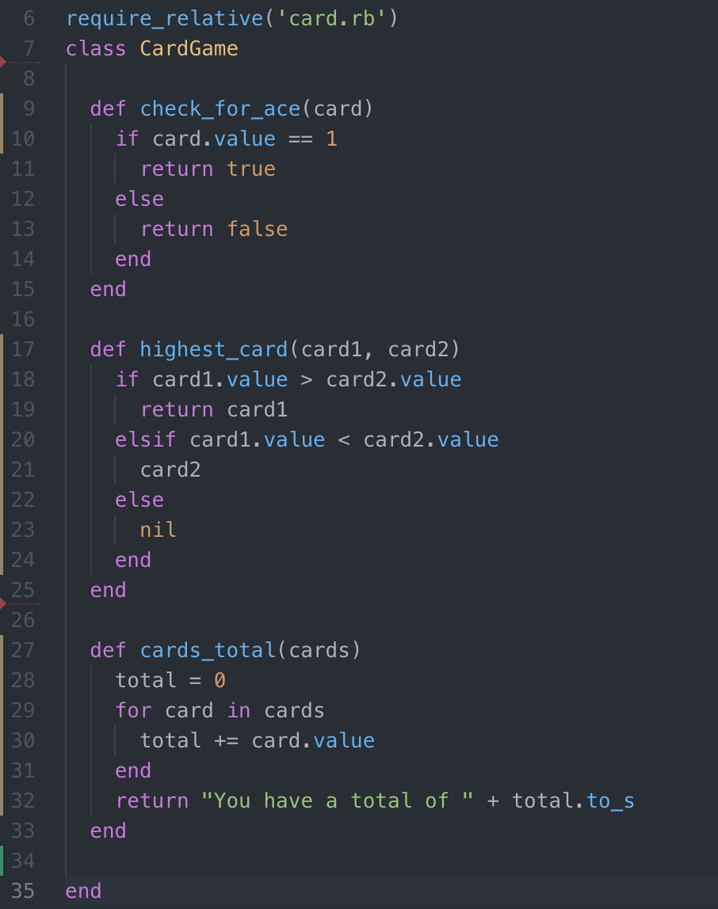

Final Corrected CardGame Class with All Errors Corrected

**Description here**

**Week 9**

| Unit | Ref | Evidence |  |
| --- | --- | --- | --- |
| P | P.1 | Take a screenshot of the contributor’s page on Github from your group project to show the team you worked with. | |
|  |  | **Description:** | |

**Paste Screenshot here**

**Description here**

| Unit | Ref | Evidence |  |
| --- | --- | --- | --- |
| P | P.2 | Take a screenshot of the project brief from your group project. | |
|  |  | **Description:** | |

**Paste Screenshot here**

**Description here**

| Unit | Ref | Evidence |  |
| --- | --- | --- | --- |
| P | P.3 | Provide a screenshot of the planning you completed during your group project, e.g. Trello MOSCOW board. | |
|  |  | **Description:** | |

**Paste Screenshot here**

**Description here**

| Unit | Ref | Evidence |  |
| --- | --- | --- | --- |
| P | P.4 | Write an acceptance criteria and test plan. | |
|  |  |  | |

**Paste Screenshot here**

**Description here**

| Unit | Ref | Evidence |  |
| --- | --- | --- | --- |
| P | P.7 | Produce two system interaction diagrams (sequence and/or collaboration diagrams). | |
|  |  | **Description:** | |

**Paste Screenshot here**

**Description here**

| Unit | Ref | Evidence |  |
| --- | --- | --- | --- |
| P | P.8 | Produce two object diagrams. | |
|  |  | **Description:** | |

**Paste Screenshot here**

**Description here**

| Unit | Ref | Evidence |  |
| --- | --- | --- | --- |
| P | P.17 | Produce a bug tracking report | |
|  |  | **Description:** | |

**Paste Screenshot here**

**Description here**

**Week 12**

| Unit | Ref | Evidence |  |
| --- | --- | --- | --- |
| I&T | I.T.7 | The use of Polymorphism in a program and what it is doing. | |
|  |  | **Description**: | |

**Paste Screenshot here**

**Description here**

| Unit | Ref | Evidence |  |
| --- | --- | --- | --- |
| A&D | A.D.5 | An Inheritance Diagram | |
|  |  | **Description:** | |

**Paste Screenshot here**

**Description here**

| Unit | Ref | Evidence |  |
| --- | --- | --- | --- |
| I&T | I.T.1 | The use of Encapsulation in a program and what it is doing. | |
|  |  | **Description:** | |

**Paste Screenshot here**

**Description here**

| Unit | Ref | Evidence |  |
| --- | --- | --- | --- |
| I&T | I.T.2 | Take a screenshot of the use of Inheritance in a program. Take screenshots of:  *A Class  *A Class that inherits from the previous class  *An Object in the inherited class  *A Method that uses the information inherited from another class. | |
|  |  | **Description:** | |

**Paste Screenshot here**

**Description here**

| Unit | Ref | Evidence |  |
| --- | --- | --- | --- |
| P | P.9 | Select two algorithms you have written (NOT the group project). Take a screenshot of each and write a short statement on why you have chosen to use those algorithms. | |
|  |  | **Description:** | |

**Paste Screenshot here**

**Description here**